Team Registration (Team Officials)

Registering Your Team
- Log into your PowerUp Sports account (or create an account, if necessary).
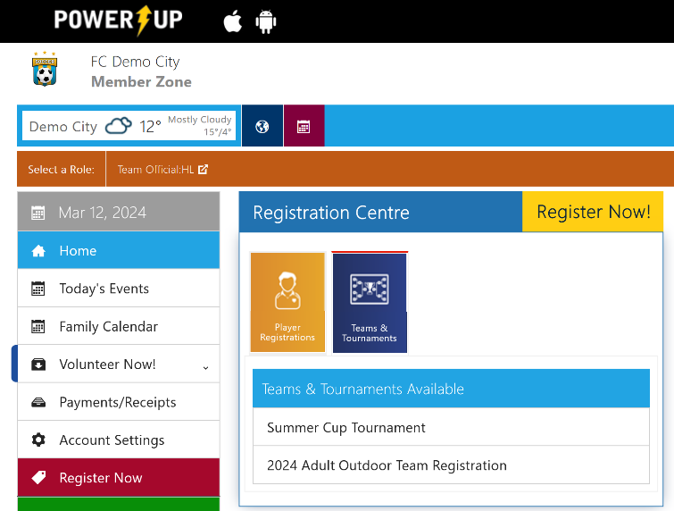
- Click the Teams & Tournaments blue icon in the Registration Centre to display the list of available Team Registrations.
- Under the Teams & Tournaments Available header, click on the relevant registration item.
- Check the box next to the Team Registration item you wish to register for and click Add to Basket.
- Review your selection, then click Check Out.
- Complete any required Additional Information, including:
  - Any waivers from the club
  - Team Name
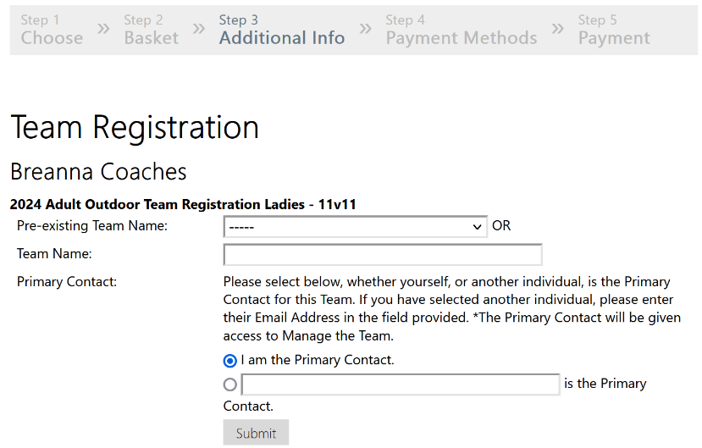
  - Indicate if you are the primary contact (or enter the email of the person who is)
- Complete payment.

Updating Team Details
Having completed the registration process, Team Officials can now manage their team, including adjusting Team Details.
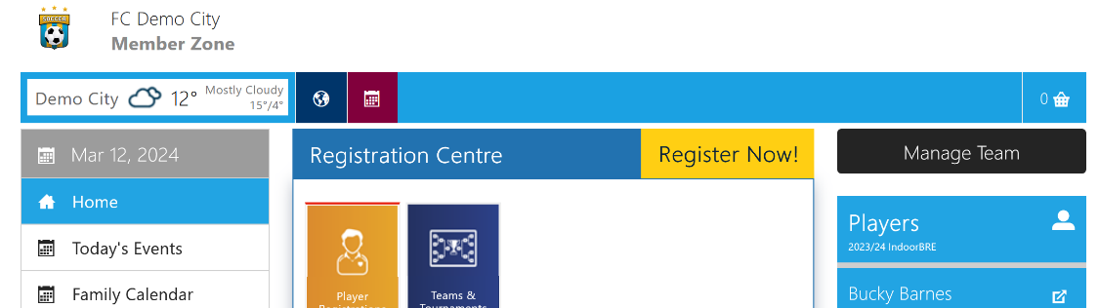
- Click the black Manage Team button on the Home Page.
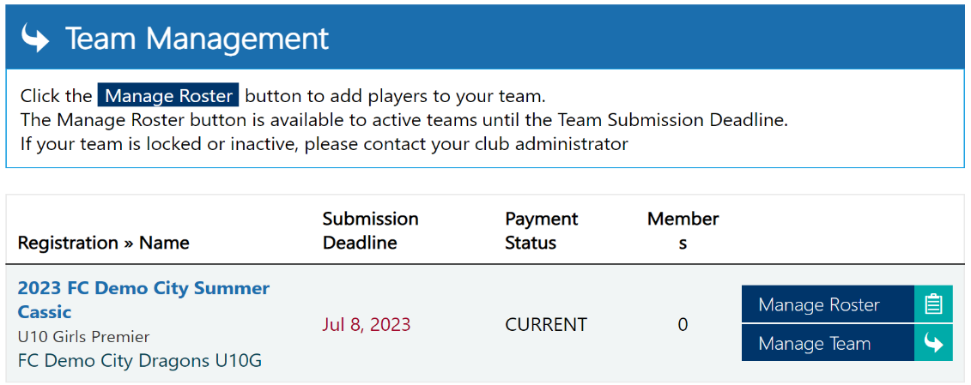
- Click the Manage Team button
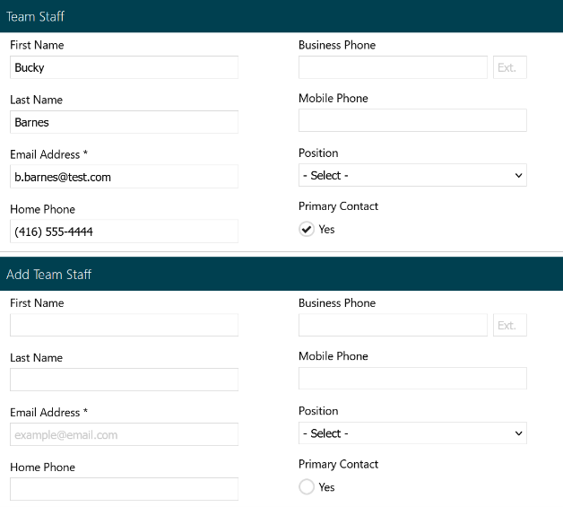
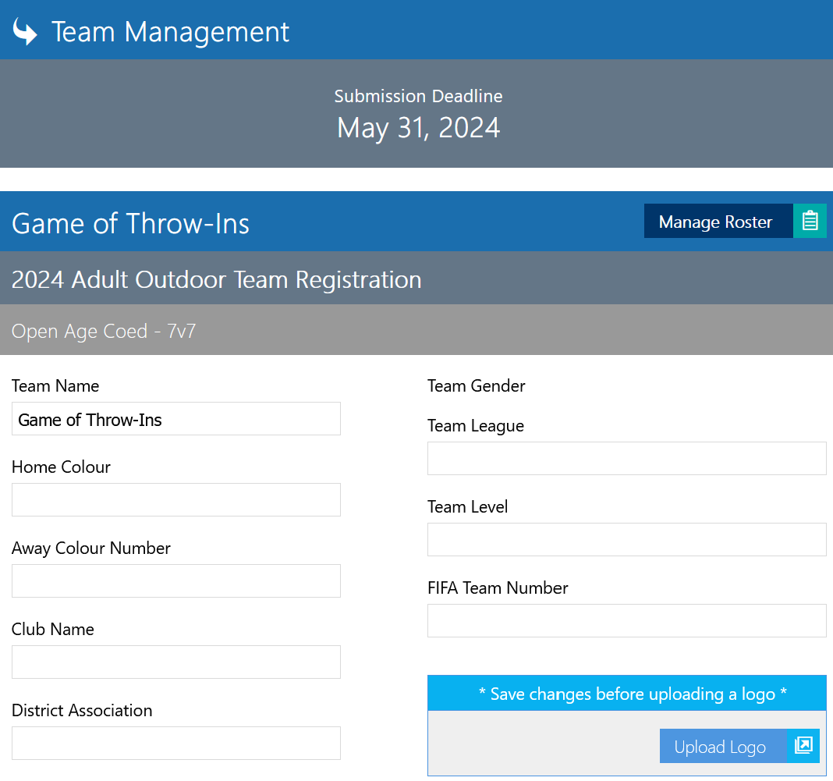
- Here you can add any other Team Details, such as jersey colours and other members of the coaching staff. Once done adding the details, click the Save button at the bottom of the page.

Managing the Team Roster
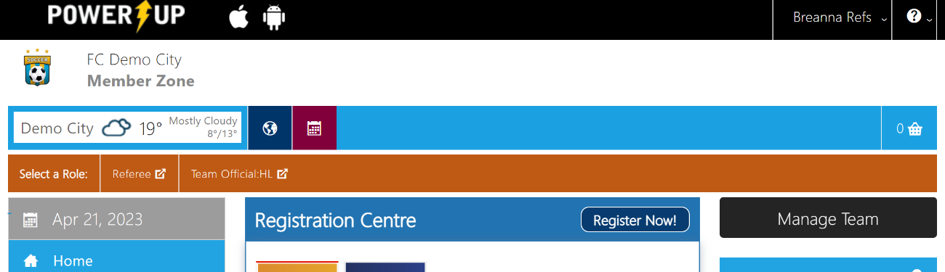
- Click Manage Team on the Home Page.
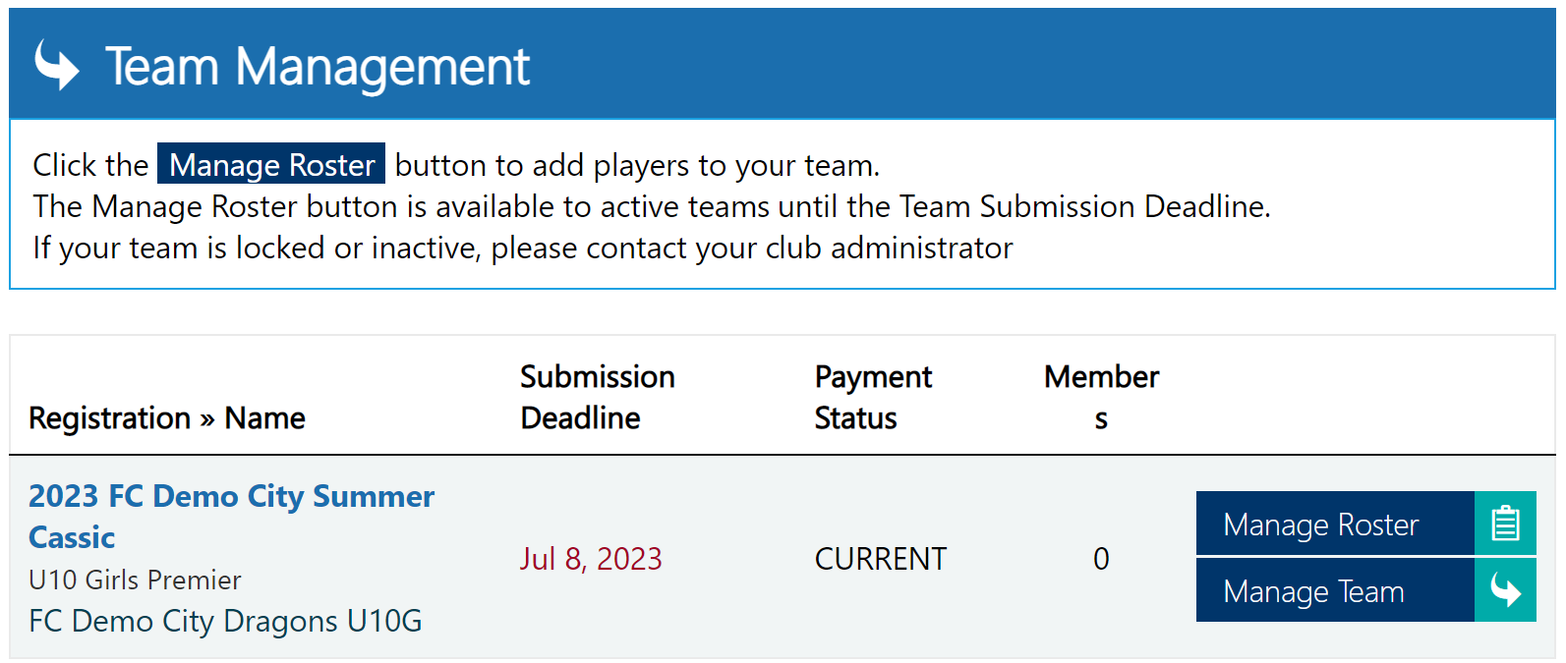
- For the desired team, click Manage Roster.
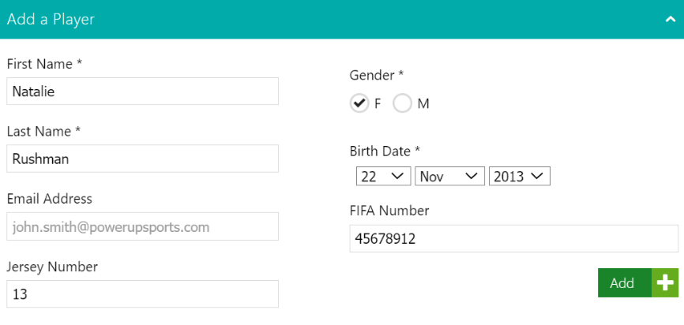
- Enter the Player Information and click Add.
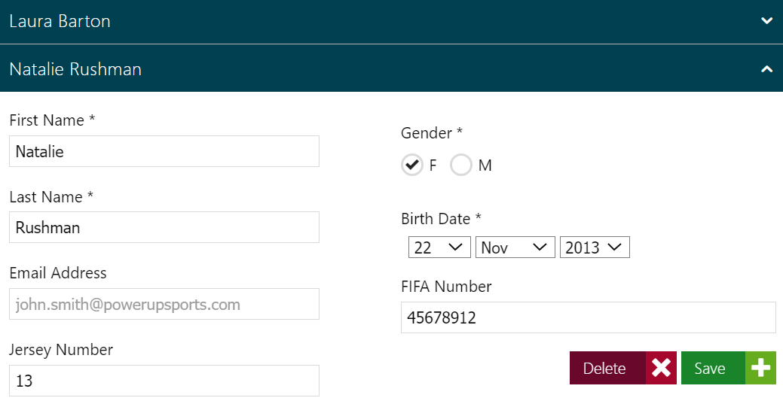
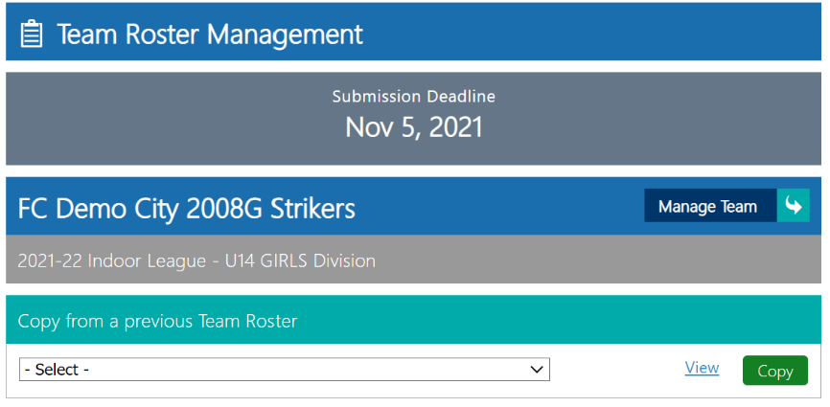
- Once added, players will list underneath the ‘Add a Player’ box. Clicking the name will open the details for review, as well as the option to save changes or delete the player from the team roster.
NOTE:
After the Submission Deadline (visible at the top of the page after clicking “Manage Team” on the Home page), the team roster will no longer be able to be adjusted.
NOTE:
If you’ve previously registered a team at the club, organization, or league you can copy the Roster rather than add players individually.

